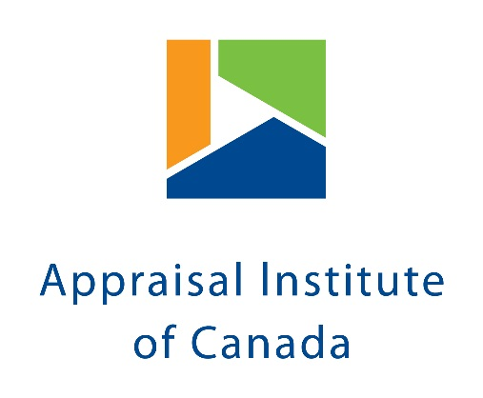

Holiday Social

You are cordially invited to our 3rd annual AIC BC FV Holiday Social.
Please register and come celebrate the season with us!
Date: Wednesday, December 7, 2016 from 5:30 – 7:30pm
Venue: Jimy Mac’s Pub
19935 96th Avenue
Langley, BC

We will meet you in the atrium

All members Free / Non-members $15.00

Cash bar
*A selection of appetizers will be provided by the AIC BC FV Chapter
We will be accepting cash donations for the Abbotsford Christmas Bureau. Did you know the Abbotsford Community Service Program serve over 300 families and 1200 children every month? We can help make the holidays a little brighter for a family in Abbotsford.

Please RSVP before December 2, 2016 so we can plan a festive event for everyone.
To register; click here

