REGISTERING FOR EVENTS ON THE APPRAISAL INSTITUTE OF CANADA WEBSITE

Click “Register Myself”. The button will change to blue and say” Cancel my Registration.”
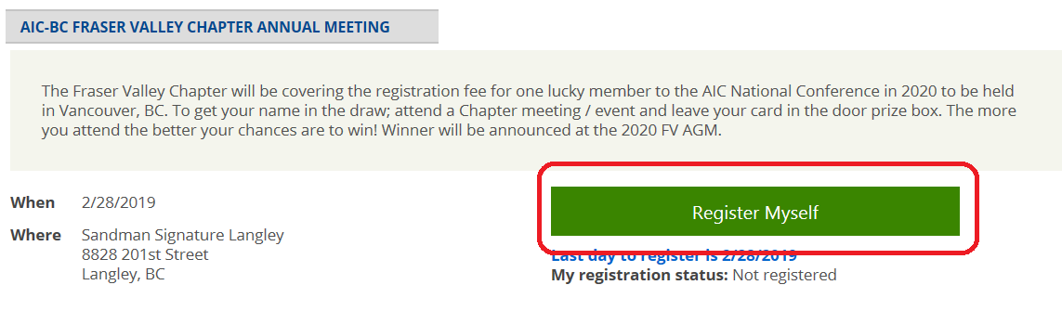

Scroll down and click on “Add”. (IMPORTANT: If you miss this step, you will not be registered.)
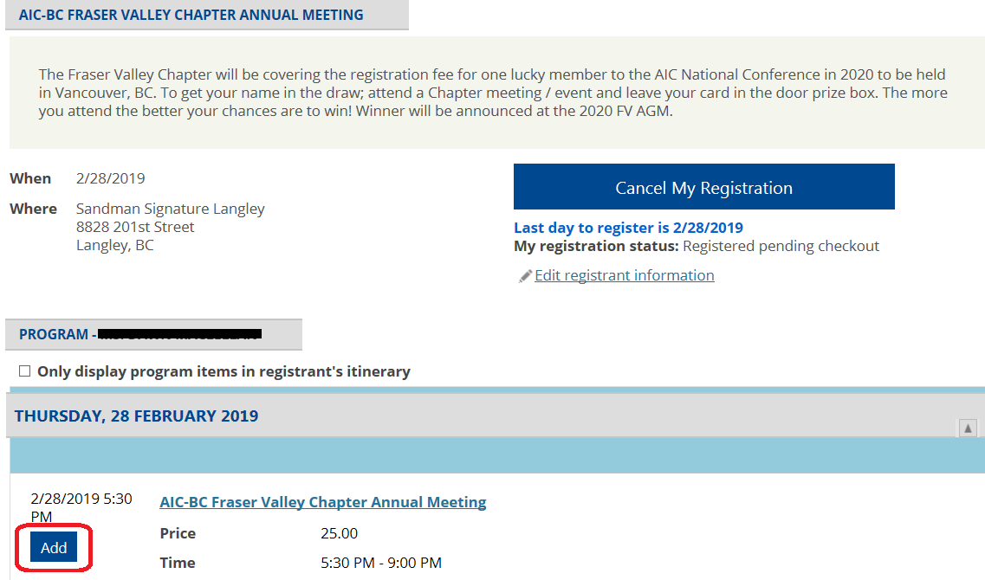

“In Itinerary” will appear highlighted in yellow near the event name.
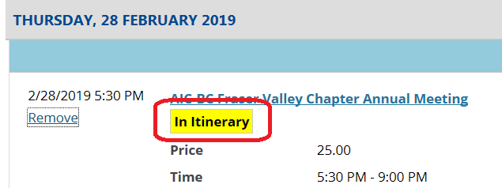

Click “Proceed to Checkout”.
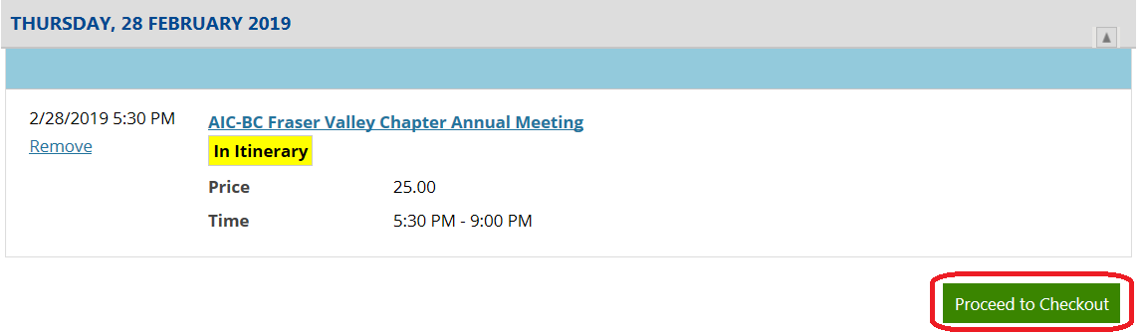

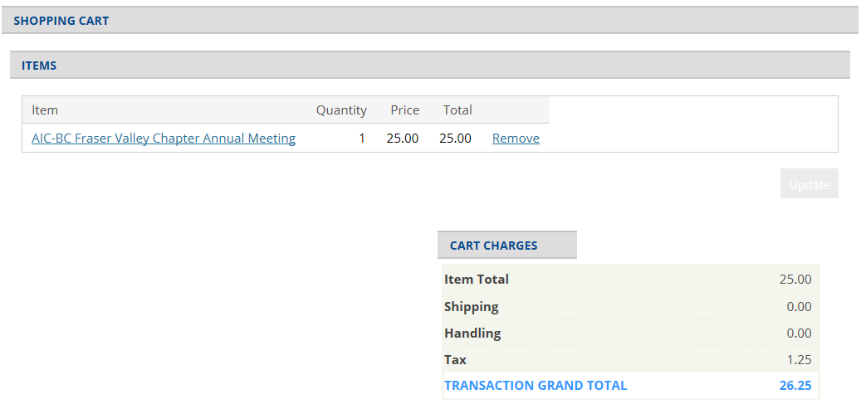
Your Shopping Cart will appear.

Scroll down, complete payment information and click “Submit”.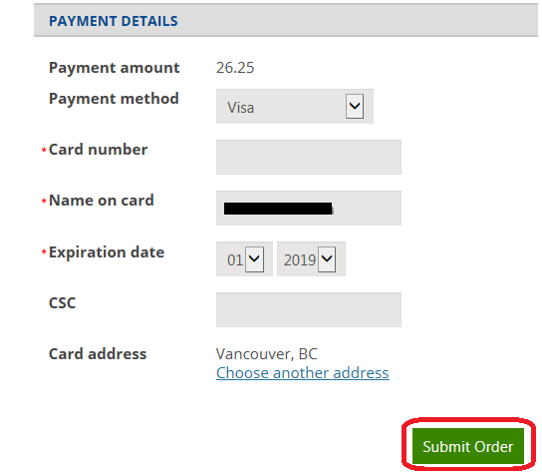
Posting of CPD Credits
If you register for an event through the AIC website, your CPD credits will be automatically posted to your record.

If you register for an event through another organization, you will be required to post your CPD credits yourself online. This includes joint AIC events when registration is handled through the affiliated organization.

